

SM6P07NI Digital Media Project

20% Research and Proposal

2025-26 Autumn

Student Name: Aryan Pradhan London Met ID: 23048423
College ID: NP01MM4A230028
External Supervisor: Pooja Shrestha
Internal Supervisor Rakshak Bhusan Bajracharya Assignment Due Date: 31st December,2025
Assignment Submission Date: 31st December,2025 Word Count: 2688

I confirm that I understand my coursework needs to be submitted online via Google Classroom under the relevant module page before the deadline in order for my assignment to be accepted and marked. I am fully aware that late submissions will be treated as non-submission and a marks of zero will be awarded.

Abstract
This project is a research-based project documenting the overall steps to be followed in the making of a studio and home theatre system.
This documentation also covers the theoretical part of the physics behind sound waves.

Table of Content
Abstract 2
Table of Content 3

Section A: Research ........................................................................................................ 1
- Introduction ............................................................................................................... 1
- Literature Review ...................................................................................................... 2
  - Sound absorption and reflective index of materials ............................................... 2
  - First Reflection Point .............................................................................................. 2
  - Comb Filtering ........................................................................................................ 2
- Measuring room Eq response .................................................................................. 3
  - Why is room Eq measurement important? ............................................................. 3
  - Room Modes and Standing Waves ........................................................................ 3
  - Types of room modes ............................................................................................ 4
        - Axial Modes .......................................................................................................... 4
        - Tangential Modes ................................................................................................. 5
- Product Review......................................................................................................... 6
  - References video no. 1 .......................................................................................... 6
    - Analysis ........................................................................................................... 6
    - Pros of the video .............................................................................................. 6
    - Cons of the video ............................................................................................. 6
    - Key takeaways form the video ......................................................................... 6
  - Reference video no.2 ............................................................................................. 7
    - Analysis ........................................................................................................... 7
    - Pros of the video .............................................................................................. 7
    - Cons of the video ............................................................................................. 7
    - Key takeaways from the video ......................................................................... 7
  - Reference video no. 3 ............................................................................................ 8
    - Pros of the video .............................................................................................. 8
    - Cons of the video ............................................................................................. 8
    - Key takeaway from the video .......................................................................... 8
- Summary and Conclusions ....................................................................................... 9 Section B: Project Proposal ........................................................................................... 10
      - Project Title ......................................................................................................... 10
      - Research Question ............................................................................................. 11
      - Treatment ............................................................................................................ 12
  - Viewers Experience .......................................................................................... 12
  - Duration ............................................................................................................ 12
  - Target Audience ............................................................................................... 12
9. Resources .............................................................................................................. 13
  - Hardware .......................................................................................................... 13
  - Software ........................................................................................................... 13
  - DIY skills and measurements ........................................................................... 13
  - Gantt Chart ....................................................................................................... 13
      - Contribution of Others .......................................................................................... 14
      - Evaluation & Testing ............................................................................................ 15
References .................................................................................................................... 16 Bibliography ..................................................................... Error! Bookmark not defined.
Appendix ........................................................................................................................ 17

Section A: Research
1. Introduction
Now a days the importance of acoustic treatments and measurements in live concerts and venues is getting more significant and people are getting more aware of the quality of the sound compared to the past days. Every sound has its own unique resonance, acoustics properties and frequency of its ambits, which is due to the reflection and resonance of the property of the materials which are used in the making of the room itself. (Acoustic Lab, 2025)
A scientist named Sabine introduced the most accurate method to calculate the reverberation time, also known as T60 of a room. This method of calculation of the reverberation of the room is based on the principle of diffuse acoustic field and lets us know the reverberation time by the formula, Sabine’s Formula = T60 = 0.161(V/A). (Acoustic Lab, 2025)
For the Digital Media Project of the 3rd year of Multimedia Technologies, I have done a research-based project on Acoustic Treatment of a closed enclosure environment. This research proves the importance of room treatment and proves the importance of it alongside the results of it in a frequency response graph.

2. Literature Review

2.1 Sound absorption and reflective index of materials
Materials in this world absorb sound frequency or reflect in some context through air medium. The ability of a material to absorb sound is known as its sound absorption coefficient ( ). In which the sound absorption coefficient value 1 means that the material can completely absorb sound whereas the sound absorption coefficient value of 0 means that the material cannot completely absorb sound and the sound absorption coefficient value of 0.5 means that the material can absorb half the sound reflected towards it and half of the quantity of the sound reflected towards it can be absorbed. (Harihar Poudyal, 2076)

2.2 First Reflection Point
First reflection point refers to the location in a room where sound waves from a speaker first bounce off a surface (such as a side wall, ceiling, or desk) before reaching the listener’s ears. If untreated, first reflections can cause comb filtering, smearing of transients, and a loss of precise left and right placement, which is especially critical in music production, mixing, and critical listening environments. (Mathias, 2025)

2.3 Comb Filtering
Comb filtering is an acoustic phenomenon that occurs when a sound is combined with a delayed version of itself, causing a certain frequency to be reinforced while others are reduced or cancelled out. This happens because the direct sound and the reflected sound arrive at the listener or microphone at slightly different times. When these sound waves interact, they create a series of peaks and dips across the frequency spectrum that resemble the teeth of a comb, thus the name comb filtering came to its term.
In a real-world situation, comb filtering occurs when the sound passed from the speakers is reflected via walls, ceilings, tables, and other different objects. Comb filtering can cause the sound to sound very thin, hollow, unnatural, phasey and so on. The comb filtering can be caused by reflection from walls, ceiling, floors, etc. in an untreated room, this can also be caused by improper mic techniques, and many more.
Comb filtering can be also reduced by using proper mic technique, treating the room with proper acoustic treatment, using directional microphones, and many more. Maintaining comb filtering is essential for achieving clean, accurate, and professional sounding audio. (Stewart, 2022)

3. Measuring room Eq response
To measure the room and analyze it, we could use different software provided all over the internet. To measure the room eq we could use free software like Room Eq Wizard and Paid software like Sonarworks, and many other software provided. We also need an RTA Mic to capture the frequency response.
3.1 Why is room Eq measurement important?
Every room has its own color due to various factors like two opposite boundries i.e. front and back walls, floor and ceilings and cause different issues like standing waves which causes issues in the audio like peaks in some certain frequencies like on low ends and makes the sound seems low and disappear in certain areas of the room. Standing waves are the main cause of acoustic distortion below the transition frequency causing peaks and dips in certain frequency response of 20db or more. (Mellor, 2015)
3.2 Room Modes and Standing Waves
Room modes are the exact frequencies where standing waves occur. Below is the frequency response image taken from XTZ Room Analyzer II Pro, where the peak in the frequency at different hertz is seen which is due to the standing waves acting harsh on the frequency response. (Acoustic Lab, 2025)
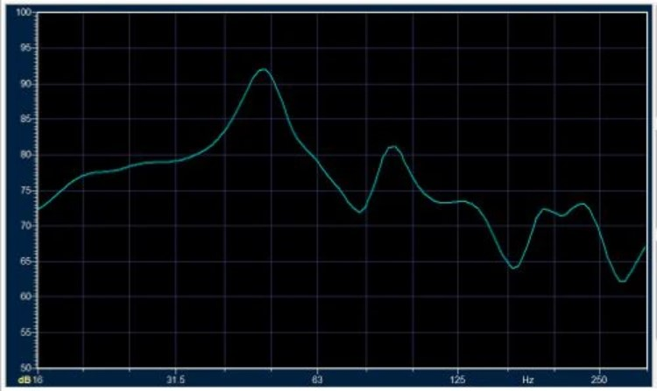

The simple way to identify Model Resonance i.e. Room Modes and Standing waves are:
- A narrow peak in the frequency response as shown in the figure above.
- Changes seen in the frequency of response and time domain behavior at certain points in the room.

Acoustic room treatment acts as a main thing a person can do to reduce the Model Resonance in the room. We could also do positional equalization like changing the position of the listening position, speakers, and subs placements.

3.3 Types of room modes

A. Axial Modes
When the sound reflects from 2 surfaces like from front wall and back wall, then Axial Mode is formed. Axial mode is considered the strongest mode and can cause significant impact on the frequency response. (Horea, 2023)

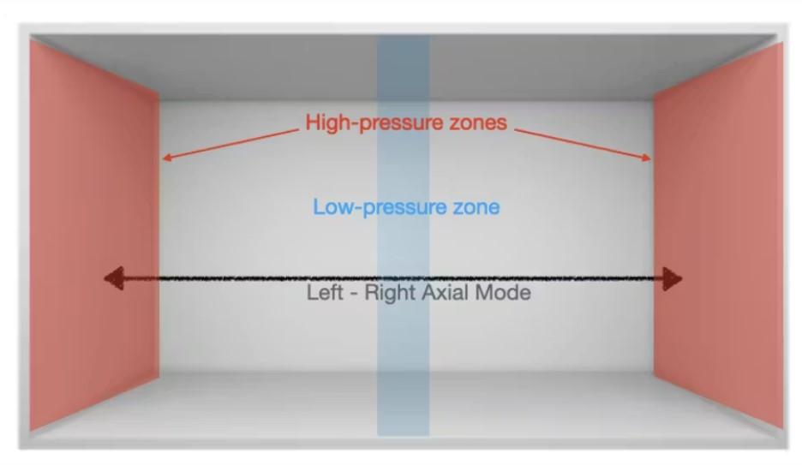

B. Tangential Modes
When the sound reflects from 4 surfaces including the front and back wall and floor and ceiling, then Tangential mode is formed. Tangential mode consists of both length and width and length and height of the room. Through, Tangential mode is half the strength of Axial Mode, its significance is also much larger in the room overall eq. (Horea, 2023)
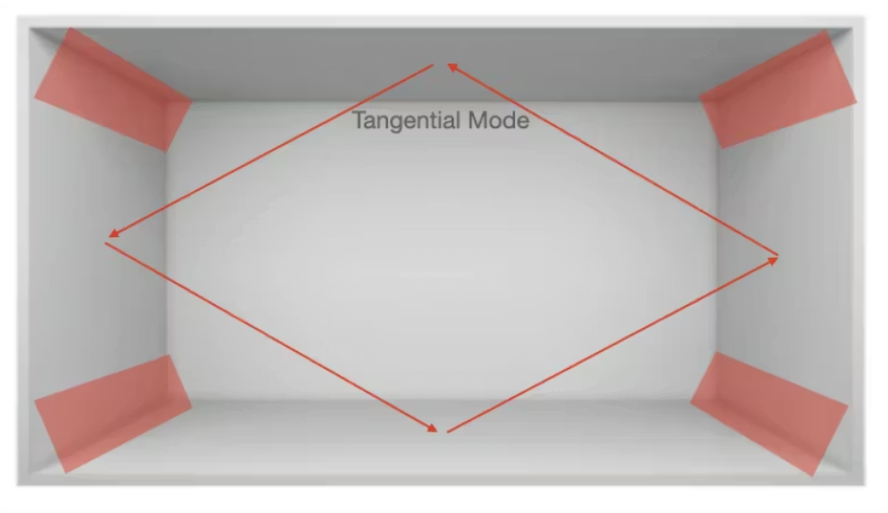

Sound Boundry Interference Response (SBIR)
SBIR also known as Sound Boundry Interference Response is a type of phase cancelation that takes place when the direct sound from the speaker is quickely followed by the reflected sound form the nearest source which can cause the reflection in the sound.

4. Product Review

4.1 References video no. 1
Building My Dream Home Recording Studio Pt. 1 by Rhett Shull https://youtu.be/hjJbm-kDkJo?si=zTjfyAdz5B5PZiWc
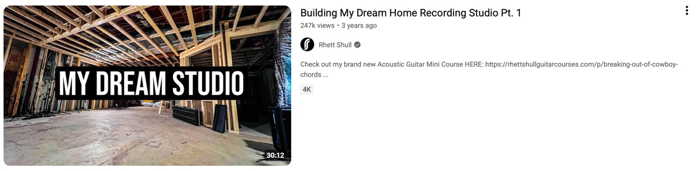 Figure 1Rhett Shull Studio Build

4.1.1 Analysis
Here in this video one of my favourite YouTube guitarist and educator Rhett Shull has demonstrated how he builds his dream studio setup from the scratch. In this video, he and another master builder had worked together to make this setup come to life.

4.1.2 Pros of the video
- This video demonstrates how the studio is built for the ground level which is very beneficial for persons who are interested in full breakdown of the process.
- In this video, he has also demonstrated how the walls, corners and ceilings construction works and affect the overall sound as well.
- This video can be very beneficial for the visual learners who are interested in both entertaining and educational contents.

4.1.3 Cons of the video
- Although this video showcased the building steps of the studio, it hasn’t included the room eq section on it.
- Because of this video being a vlog, it hasn’t included technical details like modal analysis and measurement of room eq and correction of it.
- I found that this video contains a lot of non-relevant topics like guitar playing which may be disliked by people who like to watch straight forward explanation.

4.1.4 Key takeaways form the video
- Room acoustic starts form the shape, size and materials in it and the Eq is the secondary part of it.
- Speaker's placements and listening position also matters.

4.2 Reference video no.2
Building a DREAM Home Studio: START to FINISH - No Talking! By Leo Brennauer
https://youtu.be/eKICJLmO1xE?si=pCiZA02_bksnshtS
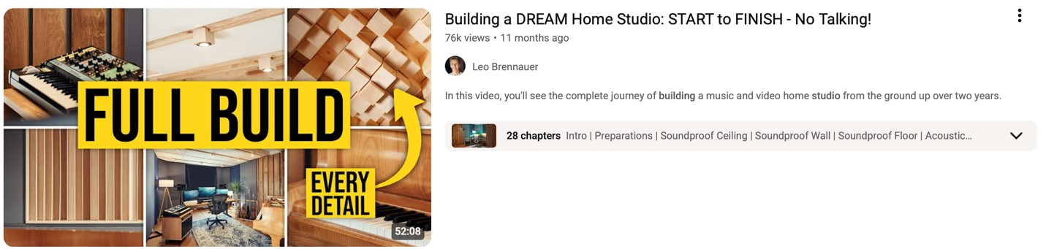 Figure 2 Leo Brennauer studio build

4.2.1 Analysis
This video shows the detail demonstration of a studio being built form the scratch including the choices of materials to measurements of the room.

4.2.2 Pros of the video
- This video has demonstrated the full journey of a studio being made including the walls, floors, ceilings, speaker placements and many other aspects.
- There is no voice or any narration in the video which makes it more straight forward to watch.
- This video also shows the dimensions and placements which shows the significance of it.

4.2.3 Cons of the video
- There is no voice or narration in the video which could make it confuse or less understanding to the people watching it.
- Through this video shows the process of measuring the room, it does not show the accurate data of the measurements.
- There is no explanation on the selection of the materials in the video.

4.2.4 Key takeaways from the video
- Even without voice or narration, we could still make our video as a roadmap for the future projects or present as a simple roadmap to another person who needs it.

4.3 Reference video no. 3
Calibrating my #homestudio using Room EQ Wizard (Step by step) https://youtu.be/Oc0aGLPfcz8?si=7AyKWoD6Ebhs_FFl
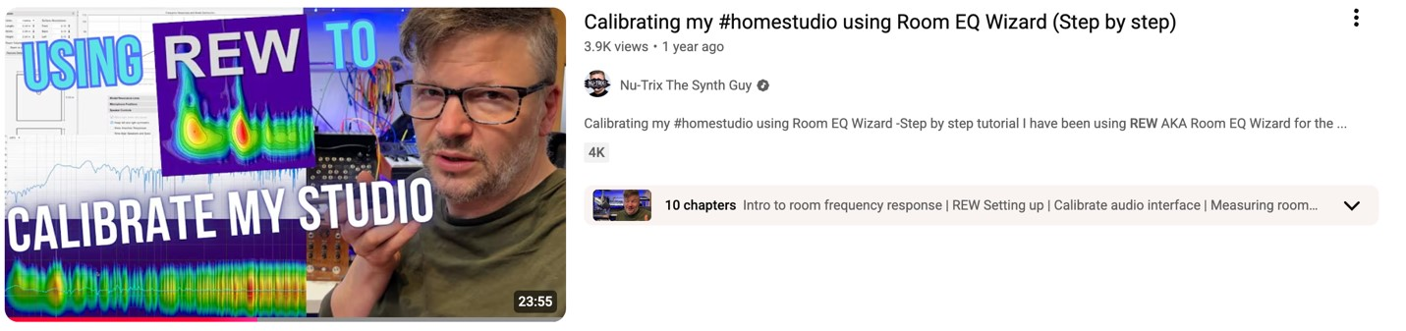 Figure 3 REW Calibrating

4.3.1 Pros of the video
- This video shows the step-by-step process of calibrating a room speaker and taking measurements using RTA microphone and Room Eq Wizard (REW).
- This video demonstrates real measurements of the actual room.
- Useful for beginners as it explains all the meat and bones of using the Room Eq Wizard (REW).

4.3.2 Cons of the video
- Lacking deep explanation on some detail topic about the room models, comb filtering and many more.
- Lacking detailed explanation on many topics which is hard to understand for beginners.
4.3.3 Key takeaway from the video
- This video shows how practical and necessary the Room Eq Wizard is.

5. Summary and Conclusions
This project can be concluded as successful in combing the knowlage in audio education and doing the handywork which is needed in the real-life situation while building the studio. All the research and planning will be used in my own studio as well as the other clients to whom I’ll work later in future. The use of room measurements and graphs will surely be useful to understand the room and its characteristics more precisely.
This project fills the void which would be lacking in the studio which we setup in our bedroom or house without knowing the materials, placements and importance of the substance in our surrounding.

Section B: Project Proposal

1. Project Title
Studio in the making
Bedroom to a secular production room.
My project is about to change a bedroom area into a professional grade studio.

2. Research Question
How does the room measurements help us to understand the room better and make it sound good?
Room measurements simply tell you the truth about your room in the context of its frequency, eq, and many more. It helps us to find out the characteristics of room which is not identified by our normal ears. Room measurements show us the peaks in the frequency, which are frequencies that are boosted by room modes, it also shows dips in the frequency which are the frequency cancelled out by room modes.
The measurements are also used during acoustic treatment, and it also helps to compare the frequency response of the studio before and after the acoustic treatment. It also helps us to pinpoint the necessary eq range. Room measurements help us to understand the hidden acoustic problems in the room and understand the room modes and standing waves more practically. Therefore, room measurements help us to create a room that is clear, control and balanced.

3. Treatment

8.1 Viewers Experience
While watching this video, the viewers will understand the basic of acoustic and room measurements. This can also help the viewers apply this theory in audio technologies and acoustic theory. Views will also understand the difference and applications between different products we use in the studio and as well as materials used in the studio.
8.2 Duration
The video will be approximately 5-10 mins long.

8.3 Target Audience
The target audience of this video will be 15 years old and above or those people who are interested in making a studio or upgrade their old once.

9. Resources

9.1 Hardware
- Universal Audio Volt 2
- M Audio Bx5 D2
- RTA Microphone

9.2 Software
- Room Eq Wizard (REW)
- Logic Pro X

9.3 DIY skills and measurements
While doing this project, I may need to do some DIY works like carpentry to make some acoustic panels in the dimension I want.

9.4 Gantt Chart
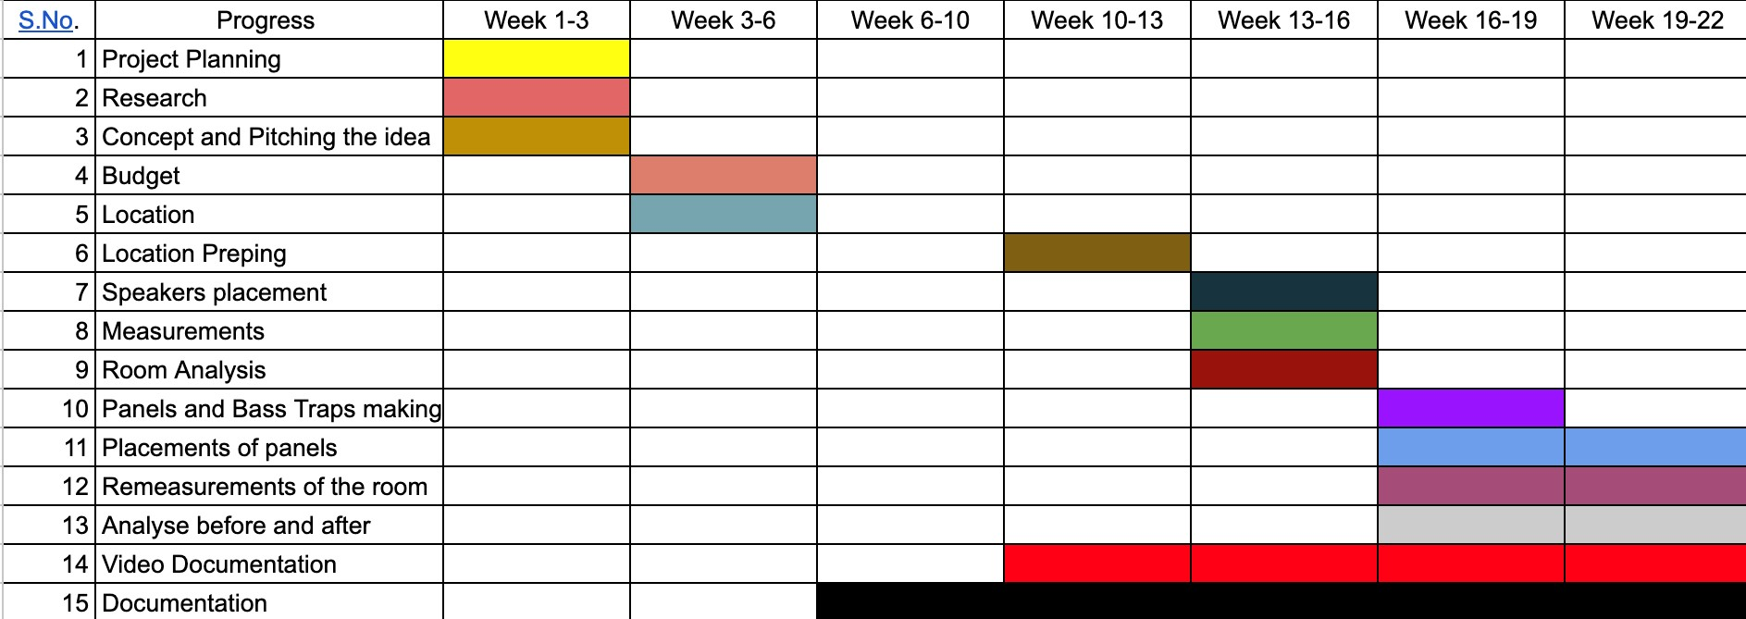

10. Contribution of Others
There would be some contribution of the technicians and helpers who will help me to build the necessary acoustic panels and bass traps, which will need to do some carpentry works but they would not help me to do the technical aspects of the project and these people would be from my office Boodles Trading.
My role in the project will be evaluating the overall construction work of panels and cables if needed and I will be conducting all the measurements and placements in the studio.

11. Evaluation & Testing
My project will evaluate and tested in the terms of the frequency response of the room before and after the treatment. There would also be sound sample of the room before and after the treatment as well.
Below here is the image of a room’s frequency curve before and after the placement of bass traps in the room.

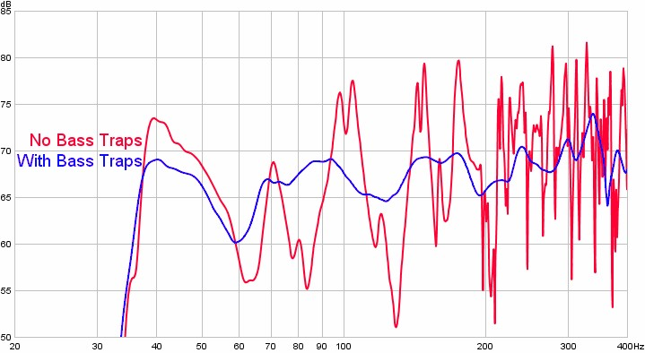
Figure 4 Before and After Bass Traps

Script

SCENE 1

Introduction about the Digital Media Project and what topic it covers.

SCENE 2

How does sound actually works in nature is explained and which fields of the problems related to sound this project solves.

It would also explains how would my project will actually helps people with the similar issues.

SCENE 3

The starting of technical details.

A. Sound absorption and reflective index of materials.

B. First relection point.

C. Comb Filtering.

D. Boundry Interference (SBIR)

SCENE 4

Explaining how the Equilization (Eq) of the room differes from each other due to the difference in size and materials inside the room.

Frequencey response is also explained and how can people from different age listens audio in different frequency range.

INT. SCENE 5

Why different types of materials is used to construct the studio and how does it differs from each other and there characteristics is also explained.

SCENE 6

3D Room tours and placement of studio items like studio monitors and desk setup along side with the placement of acoustic materials.

SCENE 7

Explaining the placements and calculating the SBIR (Speaker Boundry Interference Response) with visual representation and explaining of the mathematical calculations.

SCENE 8

Showing the before and after of frequency response after the acoustic treatment and explaining it.

SCENE 9

Finalyzing the final setup and video tour of the studio.

References
The references are taken from the industry standard people, educators and technology leading companies like Sonarworks, Izotope, REW, and many more which are listed below.
https://www.izotope.com/en/learn/what-is-comb-
filtering?srsltid=AfmBOorzwRL2Ko2Ins5-3_EJ7hDQ60b4ckuh4661KdxzIJU-nuEEdH4W https://audiouniversityonline.com/acoustic-treatment/
https://acousticfrontiers.com/blogs/articles/room-modes-
101?_pos=1&_sid=932ad2d87&_ss=r https://www.sonarworks.com/blog/learn/room-modes
https://www.acousticlab.com/en/reverberation-time-and-sabines-formula/

Appendix
Aryan Pradhan 23048423

Bibliography
Acoustic Lab, 2025. Reverberation Time and Sabine's Formula. [Online]
Available at: https://www.acousticlab.com/en/reverberation-time-and-sabines-formula/
Stewart, I., 2022. What is comb filtering?. [Online]
Available at: https://www.izotope.com/en/learn/what-is-comb-
filtering?srsltid=AfmBOorzwRL2Ko2Ins5-3_EJ7hDQ60b4ckuh4661KdxzIJU-nuEEdH4W
Mellor, N., 2015. Room Modes 101. [Online]
Available at: https://acousticfrontiers.com/blogs/articles/room-modes-
101?_pos=1&_sid=932ad2d87&_ss=r
Horea, T., 2023. Sonarworks Blog. [Online]
Available at: https://www.sonarworks.com/blog/learn/room-modes
Mathias, K., 2025. 3 Effective Acoustic Treatment Plans for Studios. [Online] Available at: https://audiouniversityonline.com/acoustic-treatment/
Harihar Poudyal, M. K. T. A. K. G. B. R. A. P. R. P., 2076. Principle Of Physics. Kathmandu: Ayam's.

